**Project Design Phase-I** - **Solution Fit Template**

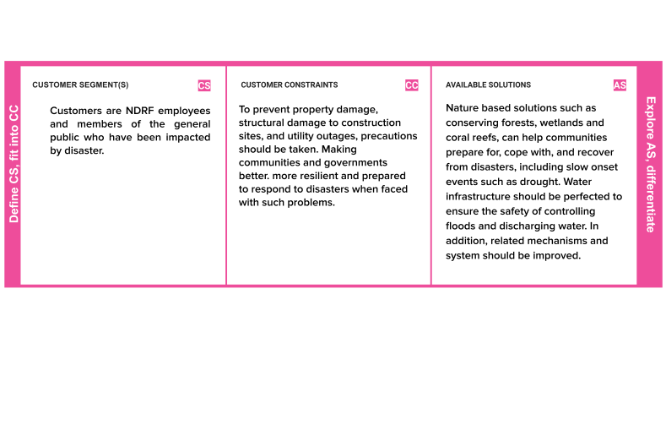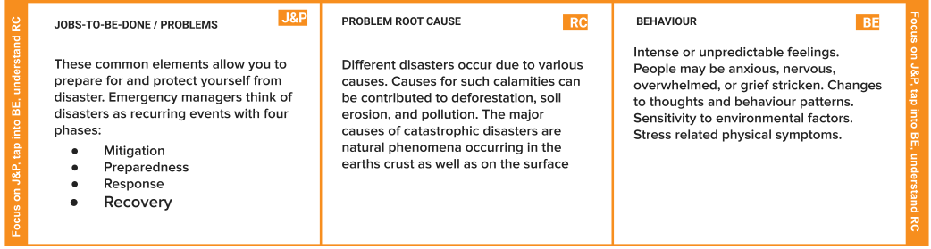

**Project Title:**

**Team ID: PNT2022TMID18733**

